LONDON MAKERS HIGHLIGHT
AUCTION OF MODERN &
VINTAGE SPORTING GUNS

A FINE and rare 16-bore self-opening sidelock ejector gun by renowned London maker Boss & Co is among the highlights of Gavin Gardiner’s auction of Fine Modern and Vintage Sporting Guns on Tuesday, April 15, 2008 at Sotheby’s Olympia (Hammersmith Road, London). Built in 1938 for the Second Lord St Levan (1857-1940), the gun remains little used and retains a remarkable amount of its original finish. Built with a selective single trigger, it is one of only a handful of 16-bore guns that Boss built using their self-opening action. Contained in its original case it is expected to sell for between £14,000 and £18,000.
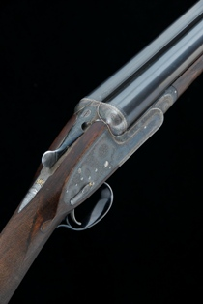

The sale will include almost 200 lots of fine sporting guns, rifles and shooting accessories. Also of note is a scarce 12-bore sidelock ejector over and under gun by J. Purdey and Sons, which is estimated at £38,000 to £46,000 and remains in a little used condition.
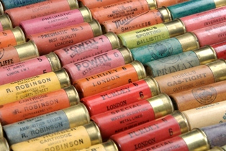
A large and comprehensive collection of shotgun cartridges is also offered in the sale. Comprising over 500 individual cartridges, the collection covers nearly all of the UK gunmakers and retailers from the last 120 years. The result of lifetimes collecting this is one of the more significant cartridge collections to have come to the market in recent years.

A large selection of vintage hammer guns will be included in this auction as well as pairs and single guns by all of the major makers.

Gavin’s next auction of Fine Modern & Vintage Sporting Guns will be at Gleneagles Hotel, Perthshire, Scotland on Monday, August 25, 2008.

For further information please contact 01798 875300 or 07831 645551
or visit www.gavingardiner.com

For Press Information only,
Please contact Rachel Aked
Email: info@gavingardiner.com
Tel: 07790 732448

February 2008

