FASCINATING COLLECTION OF ITEMS RELATING TO ELEY KYNOCH
TO BE OFFERED IN SALE
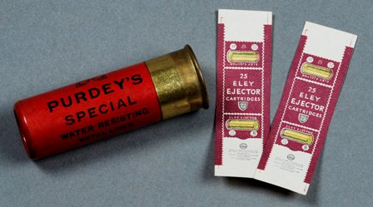

TWO miniature paper wrappers that were produced for the miniature cartridges built for King George V’s miniature pair of shotguns are part of a collection of items relating to Birmingham ammunitions manufacturer Eley-Kynoch which will be offered in Gavin Gardiner’s auction of Fine Modern and Vintage Sporting Guns on Tuesday, April 15, 2008 at Sotheby’s Olympia (Hammersmith Road, London).

Discovered, stored in an ammunitions catalogue, dating from 1936, the small paper wrappers measure less than one inch and were made for the pair of full-working Purdey hammer ejector guns (exactly 1/6 of the size of a pair of 12-bore guns) produced to celebrate the King’s Silver Jubilee in 1935. The wrappers, which were kept as samples, are estimated at £100-£200. The guns and a complete box of 25 cartridges are now preserved in the Royal Gun Room at Sandringham

World famous Eley-Kynoch had a factory in Witton, Birmingham from 1862 through to 2003 and the auction will include a wide range of objects relating to its history. These include a rare 12-bore

’Field Proof Gun’ which is engraved Kynoch Collection and was used to measure recoil and proof pressure (Estimate: £1,000-£2,000) as well as a group of advertising boards and display items (Estimate: £300-£500).
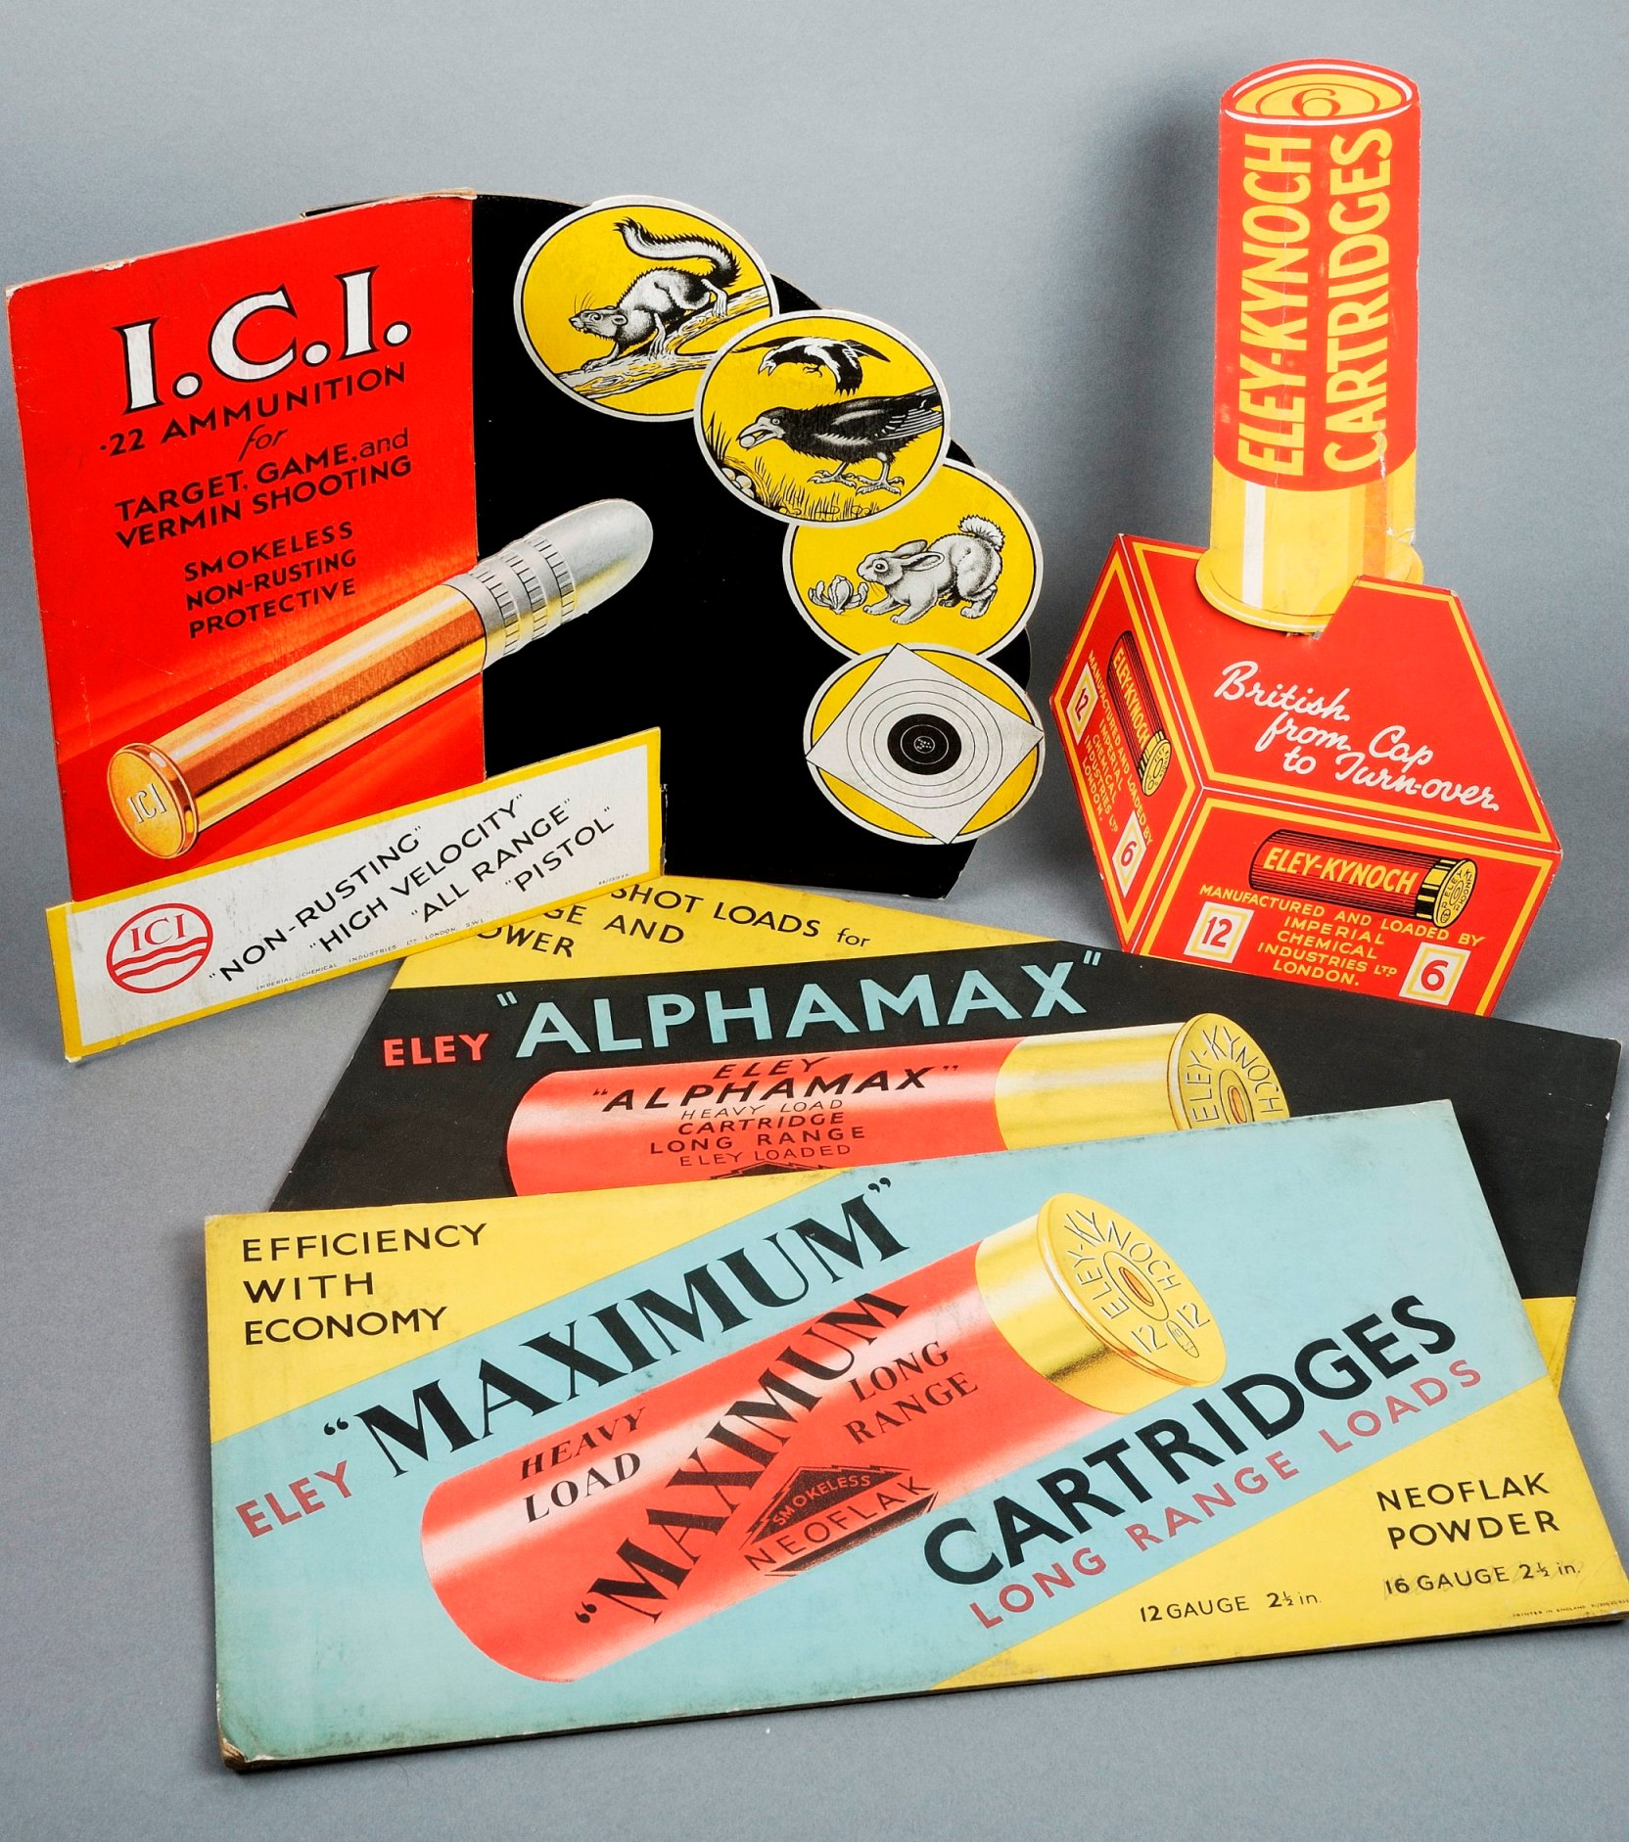

George Kynoch established the Witton factory in 1862, when he moved his existing business from the center of Birmingham to the then green fields of Witton. Initial production was percussion caps but soon all types of shotguns cartridges, rimfire cartridges and miliatry small arms ammunition were being made there.

The First World War resulted in a huge increase in demand for rifle and machine gun ammunition and many new buildings were added to the factory. At its peak the factory was producing 25 million cartridges a week. In 1918 the well established firms of Eley Brothers, Kynoch ltd, and Nobel Explosives were merged to form Explosives Trades Ltd, later renamed as Nobel Industries Ltd. The historic factory continued producing ammunition until 2003 when Eley Hawk Ltd moved to a new site in Sutton Coldfield.

A gun commissioned by the most famous name in the history of gunmaking, James Purdey, will also be offered in the sale. The fine early 12-bore self-opening sidelock, non ejector gun by James Purdey & Son, dating from 1884, was completed on July 17, 1884 for a Mr Carl Sedberg, on the instruction of founder James Purdey. It is believed that Mr Sedberg was Purdey’s son-in-law. The gun remains in remarkable condition for its age and is estimated at £10,000-£15,000 (see detail below).

Gavin’s next auction of Fine Modern & Vintage Sporting Guns will be at Gleneagles Hotel, Perthshire, Scotland on Monday, August 25, 2008.
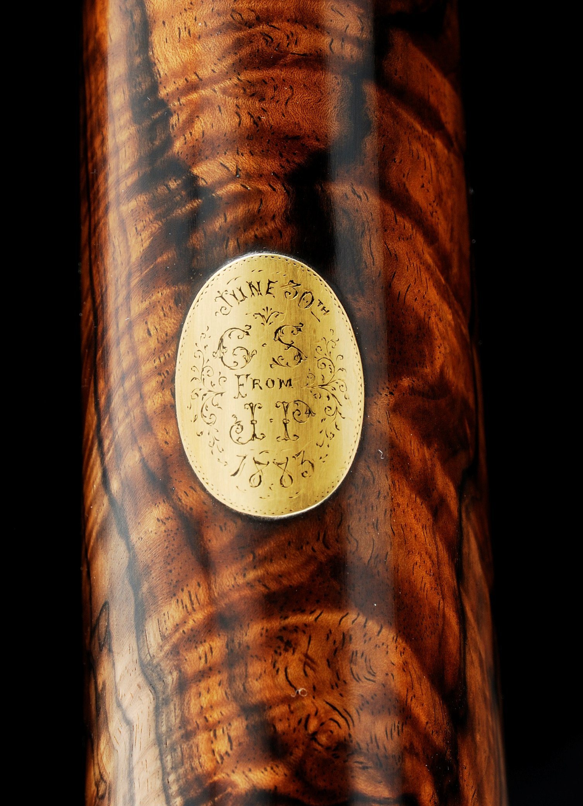

For further information please contact 01798 875300 or 07831 645551
or visit www.gavingardiner.com

For Press Information only,
Please contact Rachel Aked
Email: Rachel@rachelaked.co.uk
Tel: 07790 732448

March 2008

