GUNS BY LONDON MAKERS
ACHIEVE HIGH PRICES IN
AUCTION OF MODERN &
VINTAGE SPORTING GUNS

A FINE and rare 12-bore self-opening sidelock ejector Pigeon gun by James Purdey & Sons achieved the highest price in Gavin Gardiner’s auction of Fine Modern and Vintage Sporting Guns which was held today (Tuesday, December 9, 2008) at Sotheby’s Olympia. Built in 1956 for an American client, the gun remains little used and retains a remarkable amount of its original finish. It sold for £34,800 against a pre-sale estimate of £20,000 -30,000 to a UK Private Buyer [lot 224].
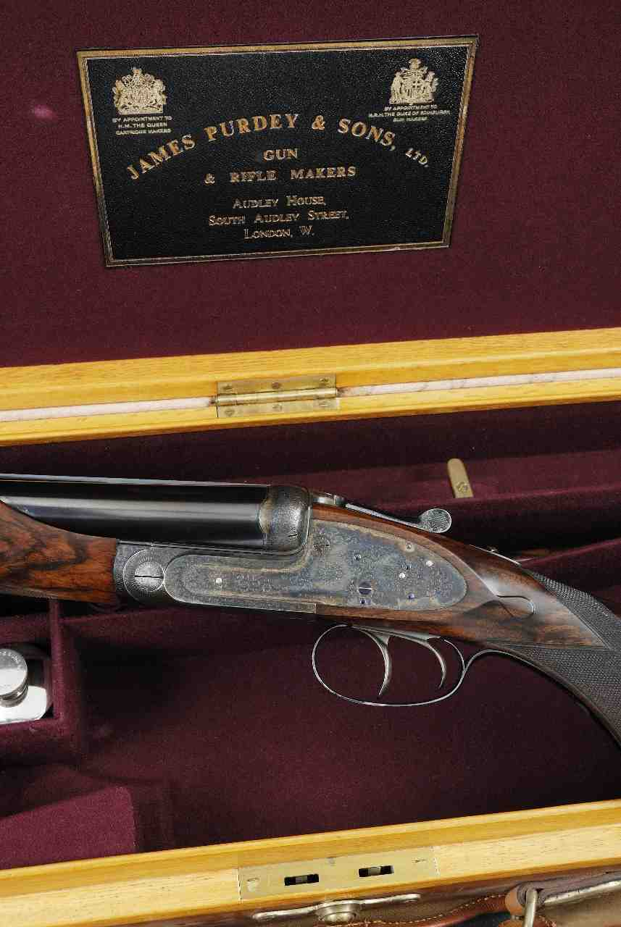

The sale consisted 372 lots of fine sporting guns and rifles as well as a large collection of shooting accessories. It attracted substantial international interest and an unprecedented amount of pre-sale enquiries. Overall, the sale totaled £300,914.

Gavin Gardiner said: “I was delighted with the very strong results among the sale especially for rare and desirable items. The Purdey pigeon gun and the Boss 20-bore round body sold especially well and I was pleased to see strong interest in the Collectors’ Hammer Guns with a Charles Lancaster 14-bore selling for £3,600. I look forward to my first auction of 2009 in April.”

Among the other highest prices of the day was a fine 20-bore self-opening round body sidelock ejector gun by Boss & Co, built in 1937 which sold for £22,800 against a pre-sale estimate of £14,000-18,000 [lot 348], while a pair of 12-bore assisted-opening single trigger sidelock ejector, also by Boss & Co and dating from 1913, fetched £19,200, which was £1,200 above the high estimate [lot 215].

It is also worth noting that among the more unusual items – a mahogany sample case of Norton’s projectiles, accompanied by a letter from Harris Holland – the founder of Holland and Holland sold for £1,320 [lot 187]; while a cased display of a cross-sectioned sporting gun by J.T Hartwell, sold for £1,560 – almost double the top estimate [lot 190] and a scarce percussion punt gun together with its 22ft punt realised £2,160 [lot 304].

A Walther.22 self-loading/bolt-action sporting rifle, which was formerly the Property of Lord Shawcross, the Attorney General, who was the chief prosecutor at the Nuremberg War Crimes Trial in 1946 sold for £780 [lot 32].

For further information please contact 01798 875300 or 07831 645551
or visit www.gavingardiner.com

For Press Information only
Please contact Rachel Aked
Email: Rachel@rachelaked.co.uk
Tel: 07790 732448

