GUN BELONGING TO
WINSTON CHURCHILL’S COUSIN
TO BE SOLD IN MAYFAIR IN APRIL

a pair of 12-bore sidelock ejector guns built for Sir Winston Churchill’s cousin as a 21st Birthday Present will be sold by Gavin Gardiner (in association with Sotheby’s) in a sale of Modern and Vintage Sporting Guns and Rifles on Wednesday, April 14, 2010 at Sotheby’s, 34-35 New Bond Street, London.
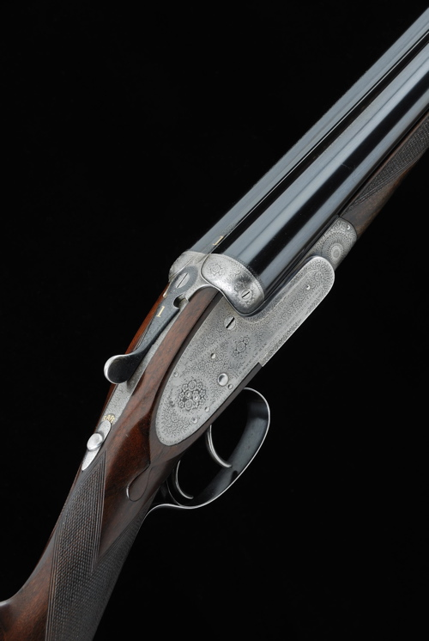

Lord Ivor Charles Spencer-Churchill (1898 – 1956) was the younger son of the 9th Duke of Marlborough and his first wife, the former Consuelo Vanderbilt, an American railroad heiress. His elder brother, John, was the 10th Duke of Marlborough. Spencer-Churchill was educated at Eton College and Magdalen College, Oxford before joining the Royal Army Service Corps in 1917 and gaining the rank of Lieutenant. He fought in the First World War and was decorated with the French Legion of Honour. He married Elizabeth Cunningham on November 15, 1947 and had a son, Robert William Charles (born 1954). He developed an inoperable brain tumor and died in September 1956. He is buried beside his cousin, Sir Winston Churchill, and close to his mother at St Martin's Church, Bladon, near Woodstock, Oxfordshire. The guns by London maker Henry Atkin, were built in 1919 and are estimated to fetch £12,000-18,000.
Gavin Gardiner is the only specialist firearms auctioneer holding his auctions in the heart of London’s West End, where he holds two sales each year as well as his prestigious sale at the Gleneagles Hotel, Scotland in August.
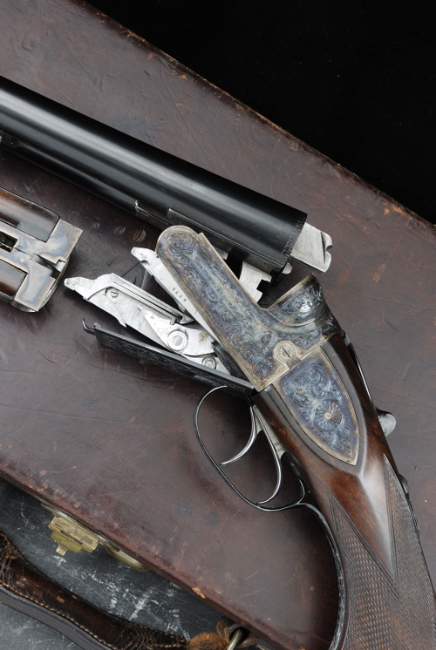
Also included in the sale will be a rare 12-bore Super Magnum Explora model hand detachable boxlock ejector rifle by Birmingham-maker Westley Richards. It is estimated to fetch £8,000-12,000

Gavin Gardiner said: “Westley Richards is a maker renowned for it's innovative guns and rifles with "hand-detachable" lockwork, which in the case of this boxlock ejector, literally drops out of the bottom of the action when the inspection cover is removed. Designed to assist Big Game Hunters in the field, who could take a spare set of locks with them to India or Africa, and should a mechanical failure occur, it would take simply a matter of moments to fit the spare replacement locks. This rare example is of the Magnum Explora model 12-bore rifle, fitted with rifled chokes, so that it could be used both as a gun and as a rifle. Innovation indeed.”

The sale will include over 300 lots of fine sporting guns, rifles and shooting accessories including pairs and singles by all of the major makers such as Boss & Co, J. Purdey & Sons, Holland & Holland and J. Woodward & Sons. Numerous single guns, as well as sporting rifles, collector’s firearms and shooting accessories will also be offered.

For further information please contact 01798 875300 or 07831 645551
or visit www.gavingardiner.com

For Press Information only
Please contact Rachel Aked
Email: Rachel@rachelaked.co.uk
Tel: 07790 732448

March 2010

