GAVIN GARDINER SHOW’S
WHO’S BOSS!

- FINE SPORTING GUNS BY LONDON MAKERS HIGHLIGHT DECEMBER LONDON SALE -
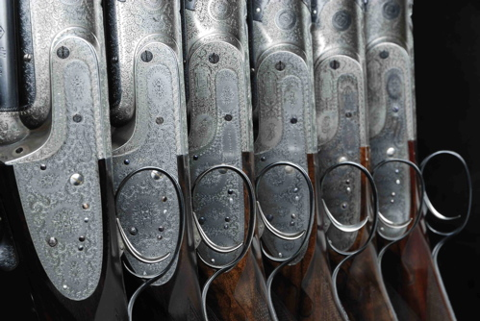

A UNIQUE collection of over and under 12-bore Sporting Guns by premier London Gun Maker Boss & Co. will be sold by Gavin Gardiner (in association with Sotheby’s) in a sale of Fine Modern and Vintage Sporting Guns and Rifles on Wednesday, December 15, 2010 at Sotheby’s, 34-35 New Bond Street, London.

The collection of six pre-war guns includes two pairs of guns together with two single examples and is expected to fetch in excess of £200,000. Estimates range from £30,000-40,000 for a single example to £80,000-100,000 for a fine pair built in 1927 and retaining much original finish.

As Gavin Gardiner explained: “The Over and Under shotgun was first patented by Boss & Co, London’s most exclusive gunmaker, in 1909 and the guns remain in production today. It is the most rev-erred of all Vintage shotguns and fewer than 500 examples have been built in the 101year history of this gun. While the "Over and Under" gun has become a common sight today, the Boss remains the most influential design and all modern designs built today are based on this original.

He adds: “Boss continue to build a very limited number of examples of this gun, with delivery taking as long as five years, and will cost just under £100,000.”

Elsewhere in the pre-Christmas sale is a scarce Holland & Holland Badminton model 12-bore sidelock ejector gun, built in 1974 as the First Annual Prize gun for W.A.G.B.I., now known as BASC, the British Association for Shooting and Conservation. Estimated at £8,000-12,000, the gun remains little used since being awarded as a prize.
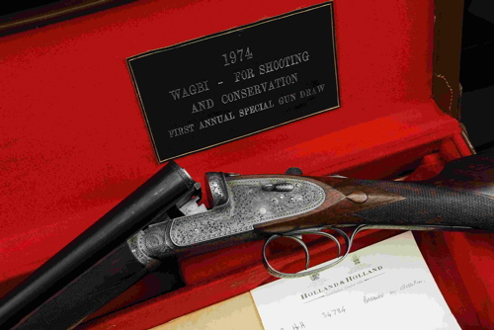

Gavin Gardiner is the only specialist firearms auctioneer holding his auctions in the heart of London’s West End, where he holds two sales each year as well as his prestigious sale at the Gleneagles Hotel, Scotland in August.

The sale will include over 300 lots of fine sporting guns, rifles and shooting accessories including pairs and singles by all of the major makers such as Boss & Co, J. Purdey & Sons, Holland & Holland and J. Woodward & Sons. Numerous single guns, as well as sporting rifles, collector’s firearms and shooting accessories will also be offered.

For further information please contact 01798 875300 or 07831 645551
or visit www.gavingardiner.com

For Press Information only
Please contact Rachel Aked
Email: Rachel@rachelaked.co.uk
Tel: 07790 732448

October 2010

