FASCINATING PROTOTYPE GUN AMONG HIGHLIGHTS OF ANNUAL GLENEAGLES AUCTION
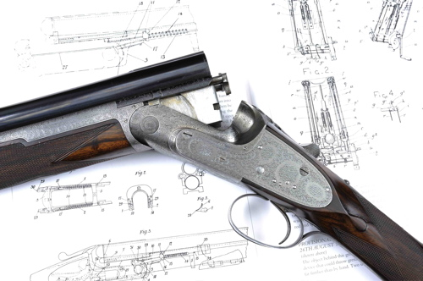

A HISTORICALLY important prototype 12-bore over and under single trigger ejector gun by London gunmaker Boss & Co.. is among the highlights of Gavin Gardiner’s annual auction of Fine Modern and Vintage Sporting Guns, which will be held in association with Sotheby's at the prestigious Gleneagles Hotel in Auchterarder, Perthshire, Scotland. The sale, now in its 44th year, will take place on the evening of Monday, August 22, 2011.

Built in 1909 this was the first Boss Over and Under gun built and was used extensively by the firm as their demonstrator to show customers the advantages of their revolutionary new design and to develop the production techniques for the guns that were subsequently built (Est: £10,000-15,000).

As Gavin Gardiner explains: “The Boss design has been copied by almost every maker since, and it truly is the father of the modern Over and Under sporting shotgun. It is still the one by which all others are judged and has never been bettered. Little over 500 examples of this historic gun have been built by Boss in the subsequent 102 years.”

Pieces by the best Scottish and English makers will be included in the annual sale – which attracts substantial overseas interest. Also of note is a Fine pair of 20-bore Royal model sidelock ejector guns by famous London-maker Holland & Holland. Built in 1912 and decorated with scroll motifs, the guns are estimated to fetch £30,000-40,000.

Highlights from the sale will be on view at the CLA Game Fair, which this year will be held at Blenheim Palace between July 22-24. Therefore it only seems fitting that Gavin Gardiner Ltd will be showing a pair of 12-bore sidelock ejector guns built for Sir Winston Churchill’s cousin as a 21st Birthday Present. Lord Ivor Charles Spencer-Churchill (1898 – 1956) was the younger son of the 9th Duke of Marlborough and his first wife, the former Consuelo Vanderbilt, an American railroad heiress. He is buried beside his cousin, Sir Winston Churchill, and close to his mother at St Martin's Church, Bladon, near Woodstock, Oxfordshire. The guns by London-maker Henry Atkin, were built in 1919 and are estimated to fetch £12,000-18,000.

Gavin Gardiner said “I am delighted to be returning to Scotland for my annual sale at The Gleneagles Hotel. This world renowned and historic auction is held two weeks into the grouse-shooting season and is a sporting highlight for shooting enthusiasts and collectors from all over the world. I am extremely pleased to say that more World Record Prices for Sporting Firearms have been achieved at this venue than at any other and the quality of the guns offered always reflects the stunning location in which the auction is held.”

Auction catalogues will cost £15 (£17 by post).
The auction is also on view at Sotheby’s New Bond Street
between August 15-16.
Follow Gavin Gardiner on Twitter @gardinga

For Further information on the auction and forthcoming valuation days, please visit www.gavingardiner.com or call 0044 (0)1798 875300

For further Press Information, please contact
Rachel Aked on 0044 (0)7790 732448 or Rachel@rachelaked.co.uk
June 2011

