AUCTIONEER RETURNS TO MAYFAIR FOR SALE OF FINE MODERN & VINTAGE SPORTING GUNS
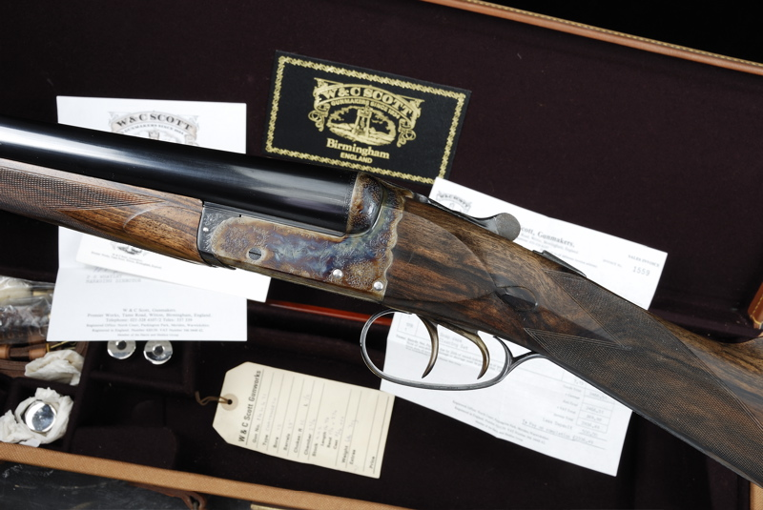

Almost 400 lots of fine sporting guns, rifles and shooting accessories will be offered for sale in Gavin Gardiner’s auction of Fine Modern and Vintage Sporting Guns on Wednesday, April 22, 2009 at Sotheby's, Upper Grosvenor Gallery, 34-35 New Bond Street, London, W1A 2AA. The sale will start at 1pm.

Gavin Gardiner said: "I am delighted to be returning to Sotheby's prestigious New Bond Street salerooms for my first sale in 2009. I have not held sales here for almost 10 years and no other Sporting Gun auctioneer now holds auctions in Mayfair, the home of the world’s finest gunmakers."

Highlights include pairs and single guns by London makers such as Holland & Holland, James Purdey & Sons, William Evans and James Woodward & Sons as well as Spanish-maker AYA and Italian-maker Abbiatico & Salvineli.

A fine pair of 12-bore sidelock ejector guns by William Evans, retaining most of their original finish are expected to sell for between £8,000-12,000, while a magnificent pair of 12-bore sidelock ejectors by James Woodward & Sons are estimated at £15,000-20,000. Among the examples by James Purdey & Sons are two pairs of 12-bore sidelock ejector guns which are each estimated at £10,000-15,000 and a single 12-bore sidelock ejector gun is expected to fetch £7,000-10,000.

An unused 12-bore boxlock ejector by Birmingham-maker W & C Scott, cased with its original invoices from 1981, and one of the last guns of this type built in the UK is expected to sell for between £2,500- 4,000 (see illustration on page 1).

Among the Continental guns is a magnificent 20-bore sidelock ejector over and under gun by Italian maker Abbiatico & Salvineli and engraved by mast engraver G. Sabatti is estimated at £18,000 - 24,000.

Shooting accessories are always popular and again, the sale will offer a great selection of guncases, placefinders, cartridge magazines and related items. Estimates start from £50. A large collection of collectors’ handguns as well as collectors’ hammerguns of all vintages will also be included in the sale.

VIEWING:
Tuesday, April 21 – 9am – 4pm
Wednesday, April 22 – 9am – 12noon

A fully illustrated catalogue will be available from Monday, March 30
and will cost £10 (plus postage).

Next Auction: Monday, August 24 at Gleneagles Hotel, Perthshire, Scotland.

For further information please contact 01798 875300 or 07831 645551
or visit www.gavingardiner.com

For Press Information only
Please contact Rachel Aked
Email: Rachel@rachelaked.co.uk
Tel: 07790 732448
March 2009

