FINE EXAMPLES BY LONDON GUNMAKERS
OFFERED IN SALE OF
MODERN & VINTAGE SPORTING GUNS
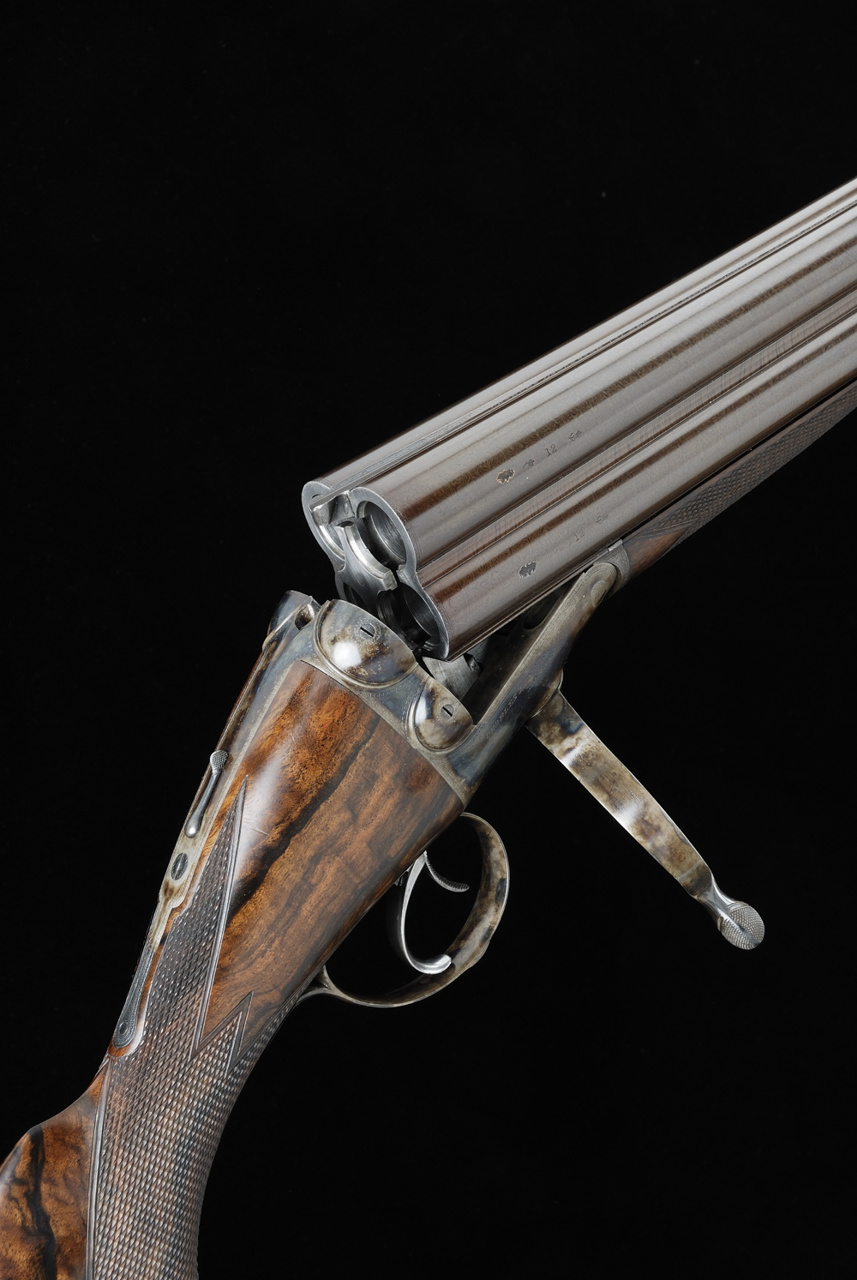
A RARE and almost unique 4-barrelled sporting gun by Charles Lancaster is expected to sell for £18,000-24,000 in Gavin Gardiner’s auction of Fine Modern and Vintage Sporting Guns on Wednesday, December 16, 2009 in the Upper Grosvenor Galleries at Sotheby's, 34-35 New Bond Street, London, W1A 2AA. The sale will start at 2pm.

Gavin Gardiner said: “Two or three barrel sporting guns are well known and are sold at auction frequently. Four-barrel guns do not come up for sale as often and I am delighted to be offering such a good example, dating from 1886, in my auction. London-maker Charles Lancaster, who was based in New Bond Street – where the auction will take place - is most well known for these type of guns although very few were actually built, so I hope that it will attract much interest.”

The sale will include more than 300 lots of Sporting Guns, Rifles and shooting accessories and among the other highlights will be an unusual Holland & Holland "Royal" model sidelock ejector rifle, which was built in 1900 for Umberto I, King of Italy. Estimated at £7,000-10,000, the rifle was completed shortly before King Umberto was Assassinated by anarchist's on July 29,1900.

A fine pair of 12-bore self-opening sidelock ejector shotguns by London maker John Rigby & Co is expected to fetch £20,000-30,000. Built in 1991 and finished to the highest standard, they remain in a little used condition.
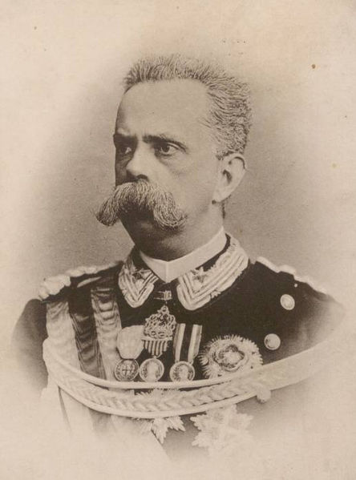

A Henry Atkin 12-bore boxlock ejector gun, built for speed legend Sir Malcolm Campbell is expected to sell for between £1,500-2,000, while a rare hammer ejector 12-bore shotgun by London maker James Purdey & Sons, built for and used by Lord Ripon, the greatest game shot of all time is expected to sell for between £30,000-40,000

A comprehensive selection of shooting accessories, gun cases, cartridge bags and magazines are also included in the sale, offering something for every shooting man and many opportunities for Christmas presents, with the sale being less that two weeks before Christmas.
VIEWING:
Tuesday, December 15 – 9am – 4.30pm
Wednesday, December 16 – 9am – 1pm

A fully illustrated catalogue will be available from Friday, November 20
and will cost £11 (plus postage).

Next Auction: Wednesday, April 14, 2010 at Sotheby’s, London

For further information please contact 01798 875300 or 07831 645551
or visit www.gavingardiner.com

For Press Information only
Please contact Rachel Aked
Email: Rachel@rachelaked.co.uk
Tel: 07790 732448
November 2009

