ANNUAL AUCTION OFFERS GUN THAT WILL BE SNAPPED UP
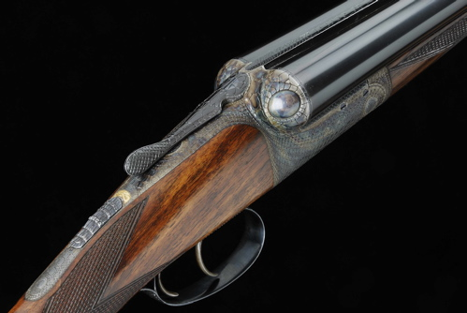

A MAGNIFICENT and truly Scottish gun, that has been engraved to look like a Crocodile will return to its country of origin to be offered in Gavin Gardiner’s annual flagship auction of Fine Modern and Vintage Sporting Guns at the world-famous Gleneagles Hotel, Auchterarder, Perthshire, Scotland on Monday, August 24, 2009. The sale will start at 6pm.

The unusual 12-bore “Crocodile’ gun by David McKay Brown, who is now based at Bothwell near Glasgow has been wonderfully engraved by highly acclaimed Goldsmith and foremost Gun Engraver Malcolm Appleby (b. 1946). Appleby, who lives in Perthshire - just 40 miles from Gleneagles has had many prestigious commissions including the Scottish Lace Gun; the Woodcock Gun; the Raven Gun (for the Royal Armories) and the Pike Gun (which sold at Sotheby’s Gleneagles in 1994) which were all inspired by nature. In addition to this, he has had many important commissions include the engraving of the orb on the Prince of Wales Coronet, the King George VI and Queen Elizabeth Diamond Stakes Trophy for De Beers, the 500th anniversary silver cup for the London Assay Office; a major silver cmmn (cup and cover) for the Royal Museum of Scotland; the seal for the Victoria and Albert Museum and the silver centrepiece for the New Scottish Parliament. He also has examples of his work in many collections throughout the world.

The round action ejector gun, which was made in 1981, has 27- inch barrels and has been engraved and carved to give the appearance of a crocodile. It is estimated at £20,000-30,000 and appears unused.

Gavin Gardiner, said: “I have been involved in Sporting Gun Auctions for more than 20 years now and have never seen a gun like this. I am delighted to be including this in my annual auction at Gleneagles, which will be held in association with Sotheby's. There has been a Sporting Gun Auction at the Gleneagles Hotel for 42 years now and I have been involved in this sale since 1987. This world renowned and historic auction is always held two weeks into the grouse shooting season and a sporting highlight for shooting enthusiasts and collectors from all over the world.
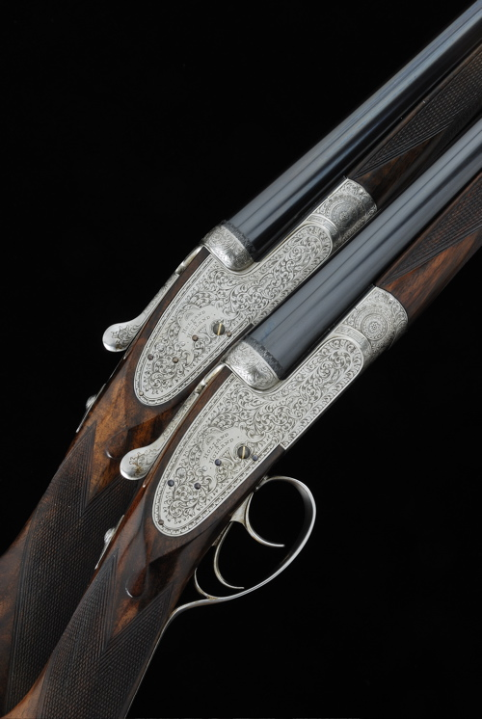

He continues: “The decoration of this gun is extremely clever and I know that Appleby has engraved it so that it does not dominate. The top extension, the frame, top-lever and furniture are all profusely engraved and carved in the most realistic style to give the appearance of the skin of a crocodile, the fences carved with the eyes and the anatomy of the beast is most accurately represented across every detail of the gun. The safety catch slides to reveal a gold serpent, signed by the engraver within the fore-end Engraved by Malcolm Appleby 1981.”

“It is an honor to bring this fine and unique example of the engravers art home to Scotland to be sold”

Elsewhere in the sale a fine pair of 20-bore “Royal” model self-opening sidelock ejector guns by London maker Holland & Holland are expected to sell for between £50,000 and £70,000. Built in 1965 the guns remain little used and retain all of their original finish [See illustration].

A rare 1 ½ bore breech-loading London pattern Punt gun by Holland & Holland, built in 1886 and remaining in a fine condition is expected to sell for between £10,000 and £15,000. With a barrel some 106-inches in length (8ft 10in, 2.7 meters) it is one of the largest Punt guns to be offered in recent years and is especially unusual as relatively few were built by Holland & Holland.

VIEWING:

London at Sotheby’s 34-35 New Bond Street

17-18 August 2009

At Gleneagles Hotel, Auchterarder, Perthshire

22-24 August 2009

A fully illustrated catalogue will be available from late July
and will cost £10 (plus postage).

Next Auction: Wednesday, December 16, 2009
at Sotheby’s, New Bond Street, London

For further information please contact 01798 875300 or 07831 645551
or visit www.gavingardiner.com

For Press Information only

Please contact Rachel Aked
Email: Rachel@rachelaked.co.uk
Tel: 07790 732448
May 2009

