GUN WITH A SCOTTISH TWIST AMONG HIGHLIGHTS OF AUCTION
AT GLENEAGLES IN AUGUST

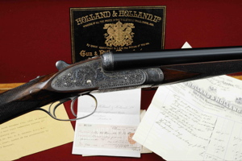

A GUN BUILT for Scottish Politician, the Rt. Hon Richard Haldane, who was noted for forming the Territorial Army in 1907 is among the highlights of Gavin Gardiner’s annual auction of Fine Modern and Vintage Sporting Guns, which will be held in association with Sotheby's.

The sale will take place on the evening of Monday, August 23, 2010 at the prestigious Gleneagles Hotel in Auchterarder, Perthshire, Scotland. This will be the 43rd consecutive year that a Sporting Gun auction has been held in this impressive location.

The fine 12-bore ‘Royal’ model sidelock ejector gun by Holland & Holland was built in 1904 and presented as a 21st Birthday present to James C. Kemp, D.S.O., M.C. Estimated at £10,000-15,000, the gun retains virtually all of its original finish and will be sold with it's original case, bill of sale for £74.14.0 and accessories. Interestingly Richard Haldane, later Viscount Haldane died in Auchterarder in 1928, so the gun has strong local connections.

Influential Liberal and Labour Politician, the Rt. Hon. Richard Haldane, was born in Edinburgh in July 1856. Educated at Edinburgh University and Gottingen University, he subsequently studied law in London and was called to the bar in 1879. A Liberal, he was elected to represent the Scottish seat of Haddingtonshire, later known as East Lothian in the 1885 General Election and as a supporter of the Boer War, he joined the government of Henry Campbell-Bannerman in 1905 as Secretary of State for War. In 1895, he helped found the London School of Economics and a few years later, went on to create the General Staff (1906) and the Territorial Army (1907). In 1911 he was granted the title, Viscount Haldane. The following year Herbert Asquith appointed Haldane as his Lord Chancellor, however it is felt that he was unfairly accused of being pro-German by the press during the First World War and he left Asquith's coalition government in 1915. He was also a member of the Fabian Society and campaigned for the Labour Party in the 1923 General Election. In 1924 Haldane became Lord Chancellor in the Labour Government formed by Ramsay MacDonald and for the next four years up to his death in 1928, he was also leader of the House of Lords. Haldane also served as second Chancellor of the University of Bristol, and was elected Chancellor of the University of St Andrews shortly before his death. He died suddenly of heart disease at his home in Auchterarder on 19 August 1928
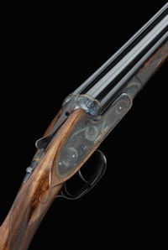
Gavin Gardiner said “I am delighted to be offering this gun with such strong Scottish connections in my annual sale at The Gleneagles Hotel. This world renowned and historic auction is held two weeks into the grouse-shooting season and is a sporting highlight for shooting enthusiasts and collectors from all over the world. I am extremely pleased to say that more World Record Prices for Sporting Firearms have been achieved at this venue than at any other and the quality of the guns offered always reflects the stunning location in which the auction is held.”

Also included in the sale will be a magnificent pair of 12-bore self-opening sidelock ejector guns by James Purdey & Sons built in 1999 and remaining virtually unused. The guns have 28-inch barrels and retain all of their original finish and hardening colour and are expected to sell for between £70,000 - 90,000.

A magnificent Presentation quality 12-bore sidelock ejector gun by London-maker Frederick Beesley is estimated at £30,000-50,000. Completed in 2006, the gun is engraved with scenes of prehistoric dinosaurs and is contained in a presentation case.

For Further information on the auction, please visit www.gavingardiner.com or call 0044 (0)1798 875300

For further Press Information, please contact
Rachel Aked on 0044 (0)7790 732448 or Rachel@rachelaked.co.uk

May 2010

