
Press Release London For Immediate Release
+44 01798 875300 gavin.gardiner@sothebys.com

Sporting Guns at Gleneagles 2008
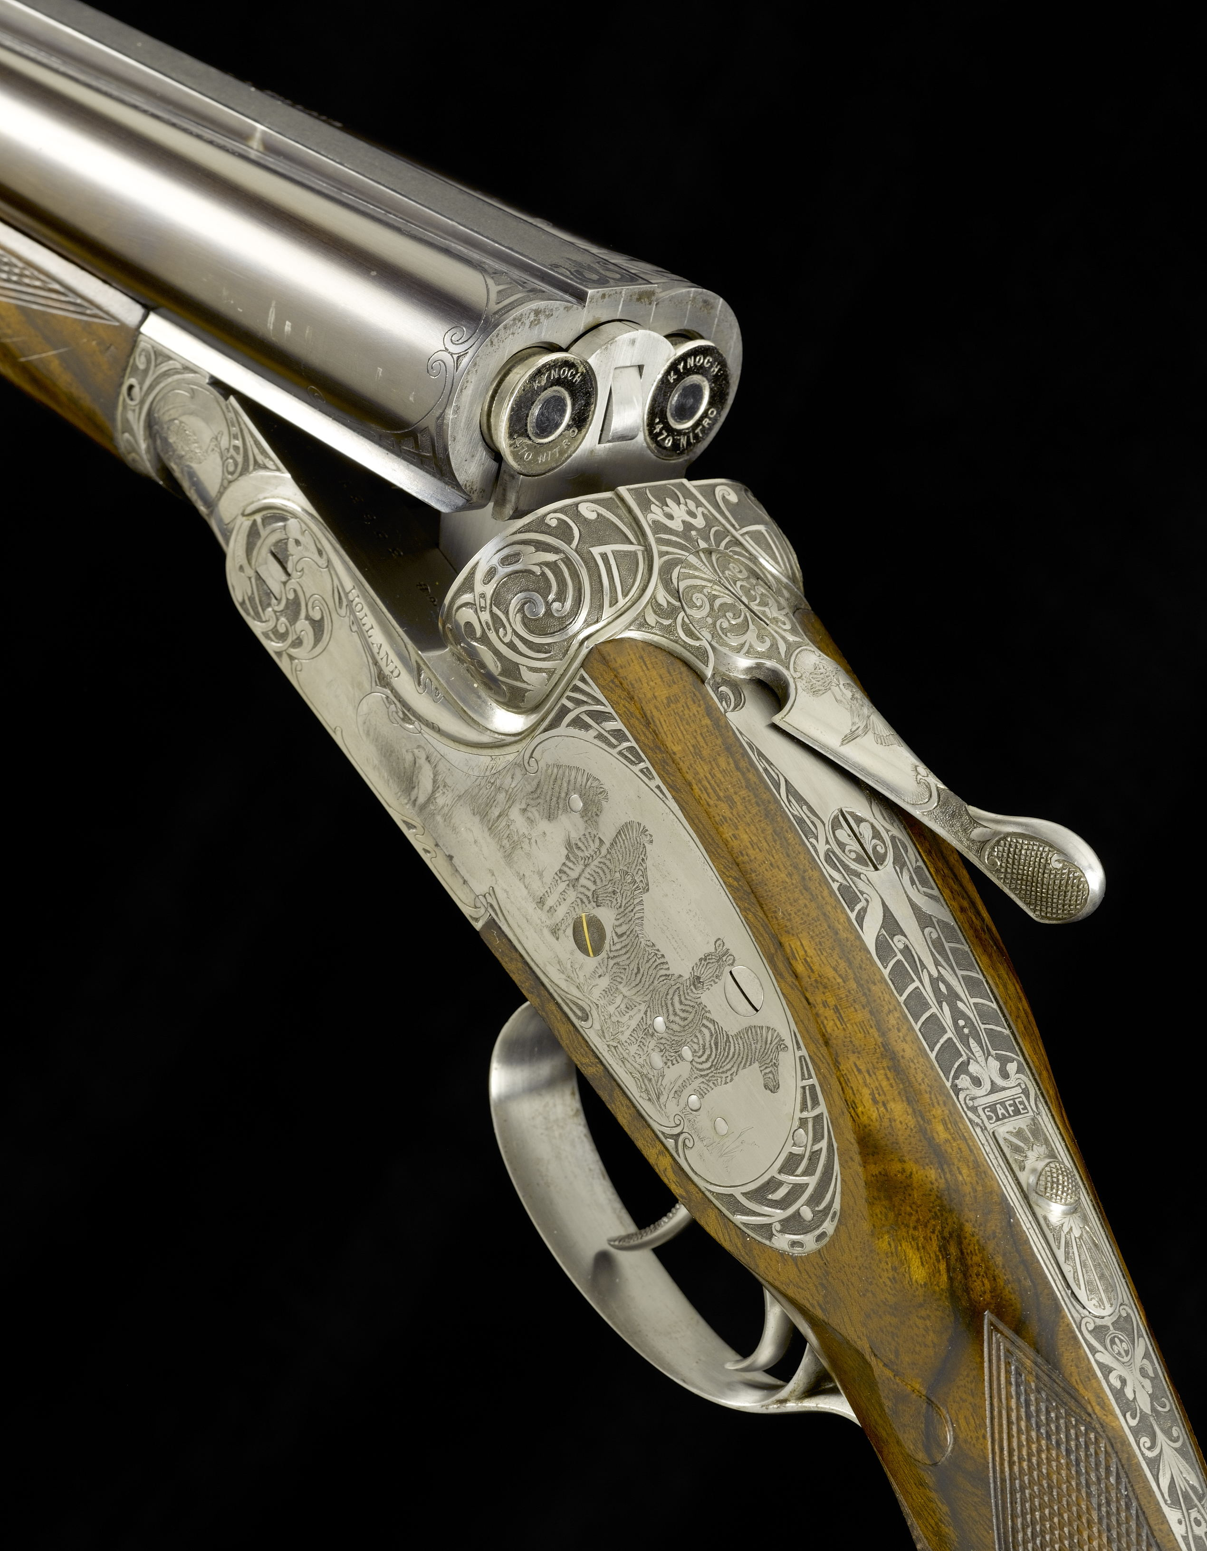

Sporting Guns by the Worlds Leading Gunmakers and Engravers are among the highlights at this years annual auction of Sporting Guns at the Gleneagles Hotel, Auchterarder, Perthshire, 25th August 2008 at 6pm.
A magnificent Holland & Holland .470 sidelock ejector rifle, profusely engraved with scenes of African game by leading female engraver, Louise Hunter. The rifle that was built in 1995 and remains almost unused and is contained in its original case with all its makers accessories. The rifle is estimated to sell for between £50,000 and £70,000.
Other highlights include a superb pair of 28-bore self-opening sidelock ejector guns by London maker Watson Bros. Engraved by Keith Thomas, the guns have a Royal theme with scenes showing the English and Scottish Palaces and residences of the Royal Family. The highly detailed and realistic work shows Windsor Castle, Sandringham and the Tower of London on one gun, with Edinburgh Castle, Hollyrood House and Balmoral on the other gun. Further embellished with scenes of English or Scottish game, roses and thistles the guns are a superb example of the engravers art. They are expected to sell for between £70,000 and £90,000.
A rare pair of 20-bore over and under guns by Italian maker Luciano Bosis, and engraved by Galleazzi with wonderful scenes of game carry an estimate of £70,000 to £90,000 and another pair by Perazzi and with work by the same engraver are expected to sell for between £40,000 and £60,000.
An extremely Fine and Rare 8-bore presentation quality double barrelled ejector gun by W.W. Greener is estimated at £20,000 to £30,000. Built in 1890 and remaining in remarkable condition this gun would have been built for shooting Duck and other wildfowl in Victorian England. Examples of this quality seldom seen rarely survive in anything like this condition.
Elsewhere in the sale, there are pairs of guns by English makers Purdey, Boss & Co, Holland & Holland and James Woodward as well as numerous single examples. Overseas makers are well represented with guns by Luciano Bosis, Beretta, Perugini and Visini, Rizzini and Browning. With numerous shooting accessories and estimates starting from as little as £500, the sale has something sportsmen and collectors at every level.
Viewing in London at Sotheby’s Olympia, Hammersmith Road, London between Monday 11th and Friday 15th August, 9am-4.30pm and at the Gleneagles Hotel, Auchterarder, Perthshire on Saturday 23rd and Sunday 24th August, 10am-5pm. The auction takes place on Monday 25th August at 6pm.

For Images and more information contact Gavin Gardiner 01798 875300 gavin.gardiner@sothebys.com

- Sotheby’s have been holding auctions of Sporting Guns and Paintings at the Gleneagles Hotel for over forty years.
- The auction is held two weeks in to the grouse shooting season at one of the Worlds premier sporting venues.
- Gleneagles is approximately 1 hour north of Edinburgh and is easily reached by road, rail and air.

Gavin Gardiner Limited in association with Sotheby’s is a leading auctioneer of Fine Modern and Vintage Sporting Guns and Rifles. Holding three auctions each year including the World Famous auction at the Gleneagles Hotel in Scotland.

